GR
Plugging into the Future: An Exploration of Electricity Consumption Patterns

Energy
group
Electricity is a vital driver of economic activity, and its consumption reflects both industrial productivity and household energy access. In 2015–16, agriculture accounted for the highest share (17.89%) of electric energy usage in India. Despite the country's relatively low electricity tariffs, its per capita electricity consumption remains below global averages, indicating both growth potential and infrastructural challenges.

The COVID-19 pandemic introduced a unique scenario for energy consumption analysis. With lockdowns enforced across India, various sectors saw drastic shifts in energy usage — some declining due to shutdowns (e.g., industries, transportation), and others rising (e.g., residential).

This project focuses on an in-depth analysis of electricity consumption patterns across Indian states from January 2019 to December 5, 2020, covering a crucial period including the COVID-19 pandemic and nationwide lockdown (March–June 2020). The dataset offers an exhaustive view of state-wise electricity usage and provides a foundation for understanding regional and national energy trends.

Scenario 1 – Change in Overall Consumption Trends

From January 2019 to December 2020, India’s electricity consumption patterns underwent significant changes influenced by seasonal demand variations, economic growth fluctuations, and the impact of the nationwide COVID-19 lockdown. Tracking month-by-month consumption over this period highlights how national electricity usage shifted compared to previous years, revealing both expected and unusual consumption patterns.

Scenario 2 – Regional Variations in Demand

Electricity consumption did not follow the same pattern across all regions of India. Northern, Southern, Eastern, Western, and Northeastern states experienced differing usage levels due to climate, industrial presence, and population density. Comparing these regions from January 2019 to December 2020 helps in understanding uneven electricity demand distribution and identifying areas of higher or lower growth.

Scenario 3 – Recovery After Lockdown

Following the COVID-19 restrictions, electricity demand began to recover, but the pace of recovery differed widely across states. Some states quickly reached or exceeded pre-lockdown levels, while others lagged behind. Evaluating this recovery phase between mid-2020 and the end of 2020 reveals how economic activity and energy needs rebounded in diverse ways.

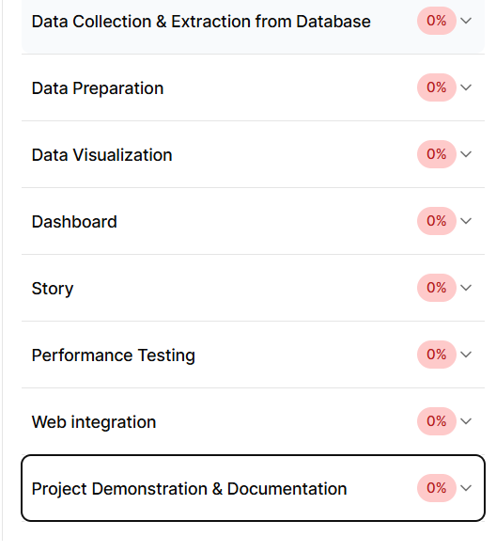
1.Data Collection & Extraction from Database
Collect the dataset
Storing Data in DB & Perform SQL Operations
Connect DB with Tableau
2. Data Preparation0%
Prepare the Data for Visualization
3. Data Visualization0%
No of Unique Visualizations
4. Dashboard0%
Responsive and Design of Dashboard
5. Story0%
No of Scenes of Story
6. Performance Testing0%
Amount of Data Rendered to DB
Utilization of Data Filters
No of Visualizations/ Graphs
7. Web integration0%
Publishing dashboard and Story to tableau public
Dashboard and Story embed with UI With Flask
8. Project Demonstration & Documentation0%
Record explanation Video for project end to end solution
Project Documentation-Step by step project development procedure

You are an expert Data Analyst and Machine Learning Engineer acting as the core developer for the project: "Plugging into the Future: An Exploration of Electricity Consumption Patterns"[cite: 2]. Your task is to build a full-stack, data-driven web application that analyzes state-wise electricity consumption trends in India from January 2019 to December 5, 2020, with a focus on the COVID-19 pandemic and subsequent lockdown phases (March–June 2020)[cite: 10].

Implement the project incrementally, adhering strictly to the following 8 core modules. Ensure the UI/UX is professional, smooth, and modern.

---

## 1. PROJECT ARCHITECTURE & CORE SCENARIOS
The application must dynamically address and allow analytical deep-dives into three explicit scenarios:
- Scenario 1 (Overall Trends): Track month-by-month consumption from Jan 2019 to Dec 2020 to highlight national electricity usage shifts compared to baseline expectations[cite: 13, 14].
- Scenario 2 (Regional Variations): Analyze uneven demand distribution across Northern, Southern, Eastern, Western, and Northeastern states, accounting for variations in climate, industrial presence, and population density[cite: 17, 18].
- Scenario 3 (Lockdown Recovery): Evaluate the pace of the post-lockdown rebound (mid-2020 to end of 2020), distinguishing between states that quickly surpassed pre-lockdown levels and those that lagged behind[cite: 20, 21, 22].

---

## 2. MODULAR EXECUTION PIPELINE

### Module 1: Data Collection & Extraction from Database
- Establish a robust mock database connection or file-ingestion layer optimized to receive the state-wise electricity usage dataset.
- Design modular extraction scripts to parse and index incoming raw transactional electricity data cleanly.

### Module 2: Data Preparation
- Implement data cleaning pipelines to handle anomalies, missing records, or date formatting mismatches.
- Perform feature engineering to bucket data by Indian geographic regions (Northern, Southern, Eastern, Western, Northeastern) [cite: 17], and add specific chronological tags for "Pre-Lockdown", "Lockdown", and "Recovery" phases[cite: 10, 20].

### Module 3: Data Visualization
- Code highly interactive, responsive visual charts using a modern charting library (e.g., Plotly, ECharts, or D3.js).
- Requirements: Include multi-line time-series comparisons for Scenario 1 [cite: 14], regional heatmaps or grouped bar charts for Scenario 2 [cite: 18], and velocity/rebound recovery slope lines for Scenario 3[cite: 22].

### Module 4: Dashboard Construction
- Integrate all charts into a unified, clean, single-page or tabbed layout dashboard.
- Features: Real-time global filter controls allowing users to dynamically filter visualizations by State, Region, and custom Date Ranges.

### Module 5: Data Storytelling / "Story" Module
- Build a dedicated, narrative-driven component within the application ("The Story Component").
- This interface should guide the user through a curated walkthrough of the 2019–2020 timeline, utilizing text descriptions juxtaposed with synchronized visual highlights to show how lockdowns drastically shifted usage from industrial/transportation sectors to residential zones[cite: 9, 10].

### Module 6: Performance Testing
- Implement benchmarking metrics to measure data rendering latency, query processing times, and UI component responsiveness.
- Ensure the application handles high-frequency dataset rendering smoothly without freezing UI threads.

### Module 7: Web Integration
- Package the data manipulation logic into a reliable backend API server (e.g., FastAPI or Node.js) and bind it securely to the frontend dashboard interface.
- Ensure state management cleanly coordinates user selections between filters and active analytical views.

### Module 8: Project Demonstration & Documentation
- Auto-generate explicit code documentation and expose an inner-app 'Help/Documentation' view detailing information about the dataset schemas, architecture, and analytical approaches.

---

## 3. TECHNICAL CONSTRAINTS & DEVELOPMENT GUIDELINES
- Strict Adherence: Do not add external feature scopes outside these 8 modules without explicit authorization.
- Design Language: Maintain a highly professional, interactive layout providing visual feedback states whenever data filters are processing.
- Maintainability: Code must be written modularly, separating data computation layers clearly from UI rendering layers.

---

## 1. IMPLEMENT: Professional Home Landing Page
- Design and build an attractive, smooth, modern Landing Page to serve as the application's root route (`/`).
- Requirements:
* Include a hero section explicitly outlining the project title: "Plugging into the Future: An Exploration of Electricity Consumption Patterns".
* Provide scannable summary cards displaying the project objectives, features, and an overview of the 8 engineering modules.
* Embed a clear, interactive Call-to-Action (CTA) button that transitions the user smoothly into the active analysis environment.

---

## 2. FIX: Real-Time UI Feedback on Filtering
- Issue: The interface remains completely static and provides no visual updates or confirmation after a user submits or updates the data filters.
- Fix: Implement responsive state management across the active view. When a user updates a filter (State, Region, or Date Range), trigger an instantaneous visual re-render.
- Requirements: Include smooth loading skeleton states or spinner animations while the data pipeline computes the newly filtered dataset slice.

---

## 3. IMPLEMENT: Dashboard Module / Analysis Display Page
- Issue: The application is completely missing a dedicated dashboard page to display data processing results.
- Fix: Build a core Dashboard page (`/dashboard`) that acts as the primary layout engine for user-driven data visualization.
- Requirements:
* Integrate the responsive multi-line charts, regional heatmaps, and trend analysis graphs directly into this viewport.
* Bind this view tightly to the filter controls so all visual components update dynamically based on the active user selection.

---

## 4. IMPLEMENT: Automated Analysis Report Generation
- Issue: There is currently no option to generate, summarize, or export the calculated data insights.
- Fix: Add an "Analysis Report Generator" utility directly within the Dashboard page.
- Requirements:
* Create an "Export/Generate Report" module that programmatically compiles the currently filtered metrics, trends, and selected timeframe into a clean summary layout.
* Provide downloadable data formats (e.g., PDF or CSV exports) or render a clean, print-ready on-screen modal containing the core text summaries and analytical KPIs.

